NMC Bookstore

Faculty Adoptions

Training Document

Table of Contents
Overview 2
Faculty and Department Sign-in 2
Faculty Adoptions 3
Completing Adoptions 5
Adoption Approvals 6

Overview
Faculty or department personnel will log in to the bookstore’s online faculty adoption website and submit their course requests or adoptions. These requests will be reviewed by the Department Approvers and/or the Bookstore where the adoptions will be accepted and/or denied. Once the adoptions are accepted the TCS Textbook adoption system will be updated with the requests automatically. If they are denied the faculty will have the opportunity to modify the adoption and resubmit them for department/bookstore approval.
NOTE: Please use Chrome as your browser for this process for the time being.

Faculty and Department Sign-in
As an individual that is responsible for adopting course materials for one or more courses, you will receive an email announcing the adoption process. The first step will be to sign in to the adoption interface by pulling up the new NMC Bookstore website and following the directions below. Note that the first time you do this, the process will be slightly different than it will be going forward.
- Either follow the link in an email that was received or go to http://bookstore.methodistcollege.edu (will be updated with the live site link.)
- Click “Login” in the upper-right corner
- First time: The first time logging in, the user will need to select the “Forgot Password” link at the bottom-right of the login window.
  - Enter your email in the “Username” field.
  - You will be sent an email from webmail@total-computing.com.
  - This email will contain a temporary password.
  - Back at the site, click again on “Login” and enter your email address and new (temporary) password.
  - To change your password, simply click the “Change Password” bullet-point under the “Manage” column (see below.)
  - Please change your password to your last name.
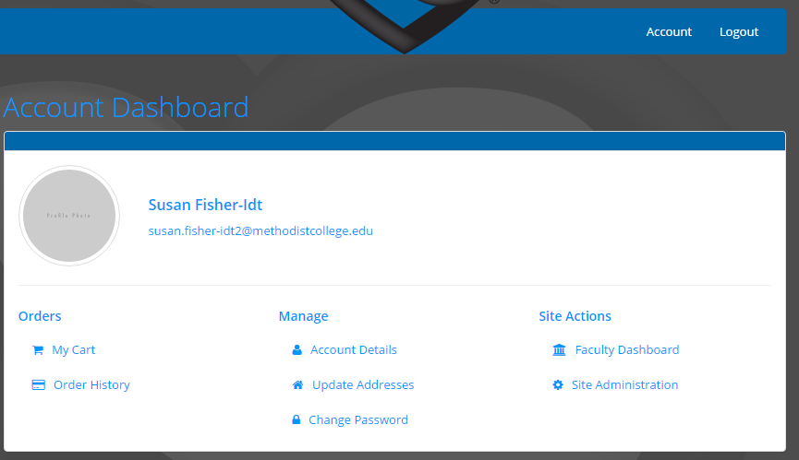

Faculty Adoptions
Once the faculty member has logged in, they are ready to adopt their course materials. Below is the step-by-step process for selecting the desired course materials.
- Click the “Faculty Dashboard” link under the “Site Actions” heading.
- From the following page, click the “Proceed to Faculty Adoptions” button with the top box under “Faculty Adoptions” (see below.)
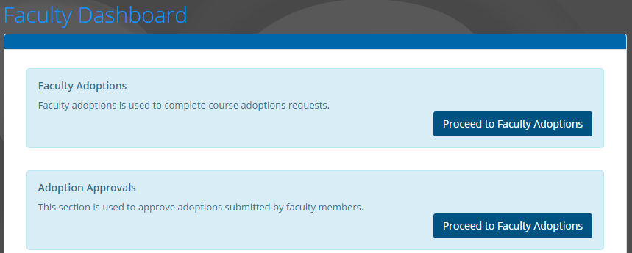
- Select the appropriate term by clicking on the drop-down menu next to “Term:” This will display a list of that term’s courses for which you are the Primary Approver.
- You will see a “Status” column that will display “New” for any new courses. These new courses will also be sorted to the top of the list.
- To select a course, click the green “Begin Adoption” button in the right column.
- The following page displays the course and allows you to update any necessary information.
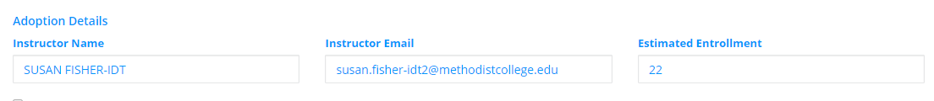
  - Begin by reviewing/updating the Instructor Name, Instructor Email and Estimated Enrollment (Please replace the number with your best guess for the enrollment number. The number visible is the current course capacity).
  - Next, if there is a book or books required for the course, click the “Add Book” drop-down menu under the “Books” heading. The resulting list will give you the following options:
    - Search in Adoption History – will show you what has been selected for this course within the last 4 years. Note: this information will not be perfect due do course numbers and sections changing over time. Please use this information as a reference only.
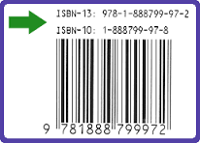
    - Search by ISBN – will give you a field to enter the text’s 10 or 13-digit ISBN
    - Search by Author/Title – you can search by entering the 1st 4 letters of the author’s last name and/or the 1st 3 letters from any word in the title. Click “Search.” Note: you can use both fields and more characters to narrow the search results.
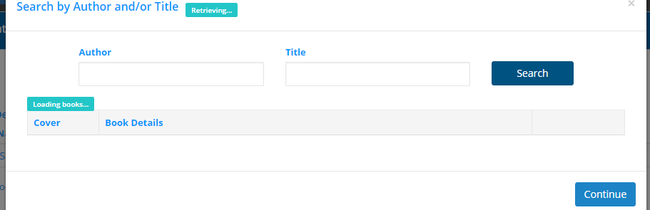
    - My Previous Adoptions – This will search adoption history for just the texts that you have used for this course in the past.

  - When the correct title is located, select it by clicking “Adopt,” located in the right-hand column. Continue to select as many texts as necessary. After finished, click the “Continue” button at the bottom-right of the page.
  - The next page will display the book or books selected. You will notice that each record contains a drop-down menu. This is where you must indicate whether the text is required. You will see several options here so select that which best applies.
  - At this point, if all information is correct, click the “Save Adoption” button at the bottom of the page. This will save the information and return to the adoption listing.

- Click “Clear Books” under the same, “Books” heading, to remove any previously selected titles.
- Click “No Textbooks Required” if there are no texts needed for the course. This will display a message that students will see indicating that there is not a textbook for the course.
- After selecting texts (or not) for a course, if the same adoptions are being used in another section, you can select “Apply to Other Adoptions” in the upper-right of the screen and this will add these text to the additional sections.
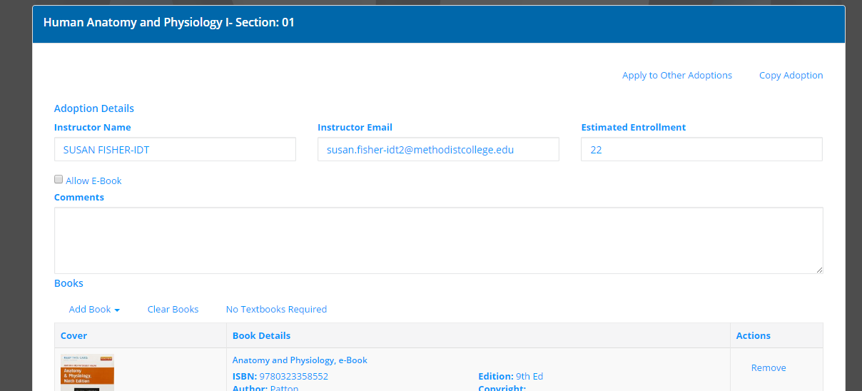
- You can also select “Copy Adoption.” This will copy all of the details of the current adoption record (from instructor to texts) and allow simple pasting into another record.

Completing Adoptions
- Once adoption selections have been made for a single course, click “Save Adoption” at the bottom-right of the page. Note that this record is not yet submitted.
- You can choose to continue completing course adoptions or, if you are finished or wish to stop and return at a later time, click “Submit Adoptions.”
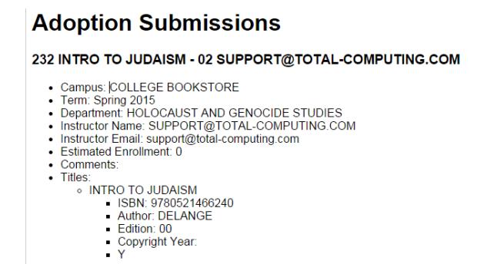
- After submitting any or all adoptions, you will receive an email that includes all the details of the individual adoptions (see example below.)

Adoption Approvals
Each course and program has been established with both a Primary Approver and a Secondary Approver. The Secondary Approver will be able to see all courses that they are responsible for and whether adoptions have been submitted for each course. To do this the Secondary Approver will log into the system following the same steps outlined above including clicking the “Forgot Password” link within the login window. The difference is that, after selecting the term, the Secondary Approver will select the “Proceed to Faculty Adoption” under the “Adoption Approvals” heading. This will lead to a page that will present all adoptions awaiting secondary approval.
To approve one or multiple records, the Secondary Approver will proceed as follows:
- Select the term and any desired filters from the 4 available drop-down menus to the right of “Selection:”
- Choose which adoptions to review by selecting them with the check-boxes to the left of each record.
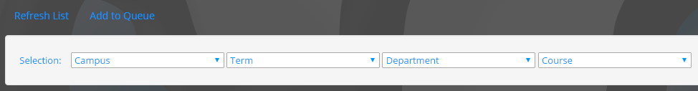
- After making your selections click “Add to Queue” at the top of the page (see below.)
- You will then proceed to the “Approval Queue.”
- The queue will list all courses that you have chosen to place in the queue. As the Secondary Approver, you will have the ability to view and modify any of the following information:
  - Instructor’s name
  - Instructor’s email
  - Estimated enrollment
  - Course materials adopted
  - Whether the course materials are required or optional
  - Student-facing notes relative to the course
- After making any necessary changes to a record, there are 2 options:
  - Click “Approve” – this will mark that record as approved and exit the queue.
  - Check “Mark as Ready” – this will allow you to proceed to reviewing subsequent records.
    - The “Approve All” button will be used when you’re ready to approve all records in the queue that you have ‘marked as ready.’
- As a Secondary Approver you will receive an email when any new adoption is available for approval so watch your email.

