Anywhere Polling using Turning Point (Clickers)
Turning Point’s Anywhere Polling allows polling atop any application.
- Insert the Turning Point receiver (looks similar to a flashdrive) into your computer.
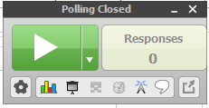
- Launch Turning Point, and select Anywhere Polling.
  - The polling dashboard should now display on the top of your screen.
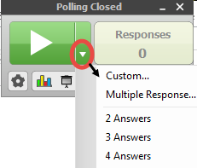
- Click the arrow to “Open Polling” for single answer responses, and/or use the dropdown arrow to choose other answer formats. The number of Responses will display accordingly.
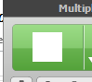
- When all responses are complete, click the the close polling button.

  - Polling results will display.

- Close the results window, and click the Open Polling button again to restart polling.

