**YuJa**

**Lecture Capture**

**Prepare:**

* **You must have a YuJa user account.**
  + Contact [NMCHelp@methodistcollege.edu](mailto:NMCHelp@methodistcollege.edu) for a user account.
* Your computer must have a web camera (built in, or webcam) and microphone (built in microphone, webcam microphone, or headset).
* The **YuJa Software Station** program **must be installed on your computer**.
  + If you are using an NMC computer, notify NMC Help for installation due to needed administrator rights.

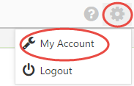**For a personal computer**, you can download and install the program after logging into my.yuja.com with your YuJa account.

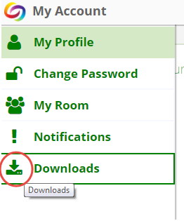After logging in, select the “Gear”, and “My Account”.

From the menu on the left of your screen, select, Downloads.

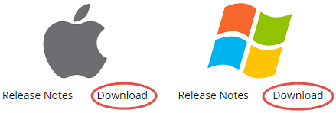Choose the download appropriate for your computer (MAC, or PC/Windows).

* **Tips for a successful recording:**
  + Be sure your recording space is free of distractions, and background noise (phones ringing, dog barking, conversations, etc.)
  + Turn off email notifications if you are recording your screen.
  + Speak normally, and clearly. You might also consider speaking a little slower than normal, if using CC (closed captioning).
  + If you are capturing/recording a slide presentation/document on your screen, **have the presentation open and ready.** It’s also a good idea to pause a couple of seconds between slides/pages.
  + If using a headset, be sure to position the mic closer to your chin to avoid puffs of air going directly into the mic.

**Ready?**

Launch the YuJa Software Station from your task bar.

**Creating a Profile**

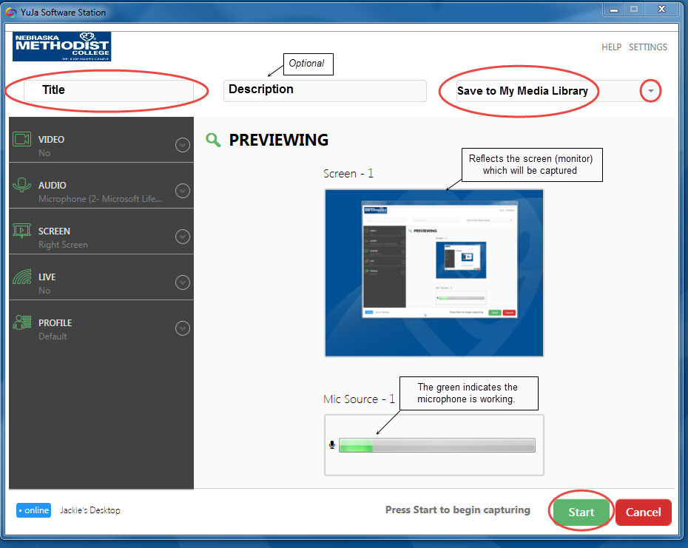The purpose of a profile is to create/save video and audio settings for the computer you will be using. If you could be using different computers for lecture captures (laptop, home), the settings (profiles) are saved **specifically for that computer**. The profile(s) you create are visible only to you.

The default/Previewing window, saves your lecture capture to your Media Library (cloud). You can use the dropdown arrow to save this capture to a particular group.

**Title, Description, Save Location**

1. Enter the title of your lecture/capture. Description is optional.
2. Use the dropdown arrow and select “Create a new device profile.” (If you’ve created profiles, you can select the appropriate profile for the computer you are using.)

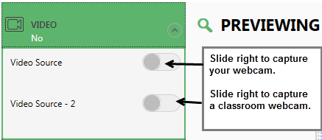**Video, Audio, Screen, Live, Profile Settings**

**Video:**

If video recording yourself, slide the control to the right.

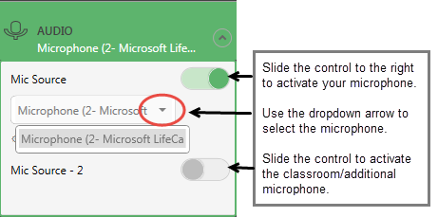If/in addition to, you are capturing the classroom, slide the control to the right for **Video Source -2**

**Audio:**

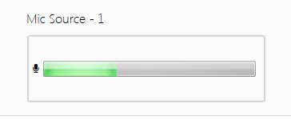To activate your microphone, slide the control to the right using the dropdown arrow to select the microphone on your computer. (Your preview window will display green in the area indicating your Mic has been recognized.)

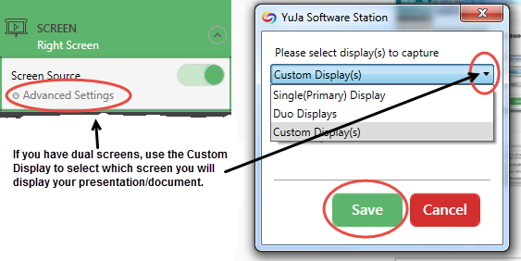**Screen:** (Capture your Presentation/Document)

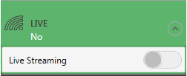Slide the control to record your screen. If you have dual screens (two monitors), use the advanced settings to choose which screen. Make sure your presentation/document displays on the chosen screen. Be sure to save your selection.

**Live Streaming**? Probably not.

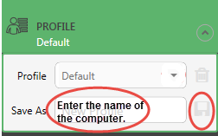

**Save/Name Profile:**

Enter the name of the computer you are using for this capture. If you have a previously saved profile, use the dropdown arrow to select the computer you will be using.

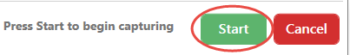**READY TO CAPTURE?**

Click Start to begin your lecture/capture.

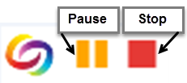Once the capture begins… look for the small control menu located at the bottom right of your screen.

* Press **Pause** if you need to pause, or **Stop** when your capture is complete.

**Accessing Your Recorded Lecture Capture**

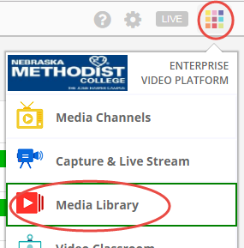Your recorded capture sent to your Yuja Cloud for rendering into a viewable video. When your capture is ready for viewing, you will receive a confirmation email. **Please be patient**, the longer your capture, the longer it will take to render into a video format.

1. Login to my.yuja.com
2. Click the “Main Menu” in the top right corner of your screen and then select “Media Library”.
3. 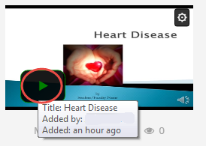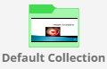Double-click the Default Collection folder that displays.
4. Locate your Lecture/Capture video and click the play button to preview your video. Return to the Default Collection.

**Linking/Embedding Your Video into Your Course**

1. Place your mouse over your video and click the gear icon that displays.
2. Select “**Details**” from the dropdown menu.
3. Click the “Links” tab below your video.
   * Copy/Paste the code to embed your video, **OR**
   * Copy/Paste the Direct Link as a bookmark to the page in your course.

