**Engaging Presentations with PowerPoint Turning Point (Clickers)**

Turning Point allows you to create engaging presentations using “polling” or question slides. Turning Point is an add on/menu item and displays **ONLY** when Turning Point has been launched, thus opening PowerPoint. Launching POWERPOINT does not add the TI menu.

The John Moritz Library reserves the clickers for checkout. There are three sets of available. Sets vary between 16-36/set for a total of 75 clickers. You can check out one/all sets as available.

**Before you begin…**

* You will need the Turning Point software installed on your computer and the classroom computer must also have this software installed. Please email NMCHelp if you have questions regarding the classroom computers.
* 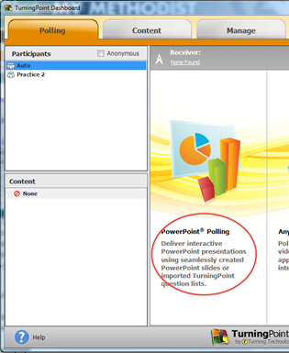You will need a set of the clickers to test your presentation. You can test your presentation on any computer with the TP software installed (your office, classroom, CREATE center, etc.).

**Let’s Begin!**

1. Launch Turning Point, and select **PowerPoint Polling** from the dashboard.
2. 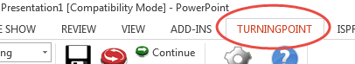When PowerPoint opens, select a Blank Presentation, or open an existing .ppt . The TURNINGPOINT menu should display. If not, click the TP menu at the top.

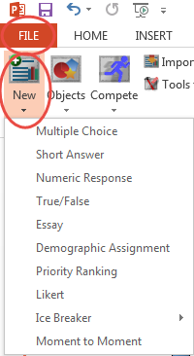If you are using an existing .ppt, select the slide where the TP slide will follow.

1. From the TP menu, click **File**, **New**, selecting the question type from the dropdown.
   * **By default a new slide will insert with the appropriate question template.** *For the purpose of this demonstration, Multiple Choice will be used.*

**Add Questions/Answer Choices, Correct Answer(s) and Correct Answer Indicator**

1. Click and enter the question text in the area indicated on the slide.
2. 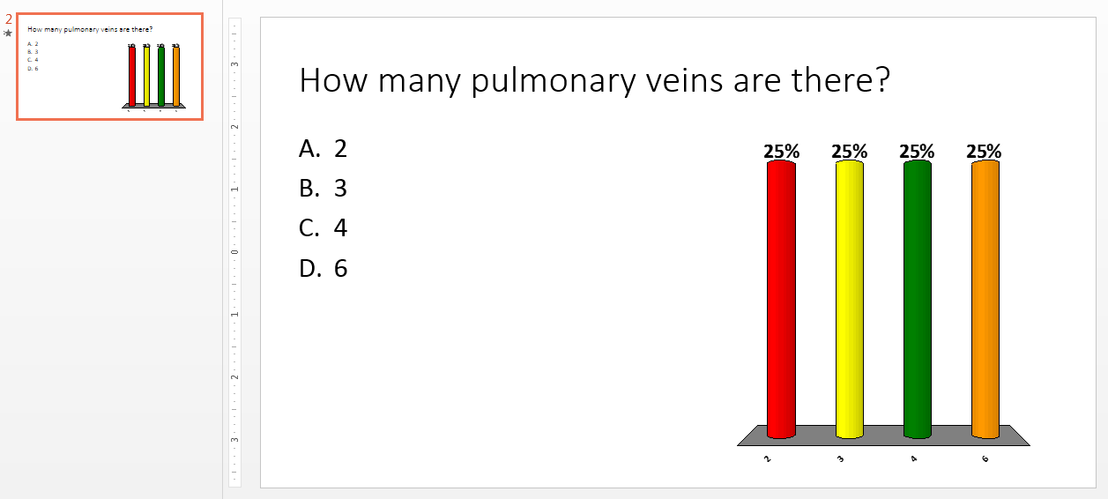Click and enter the answer choices. Press the Enter key to enter a new answer. The bulleted format will appear by default, as well as a response graph, similar to the image below.
3. 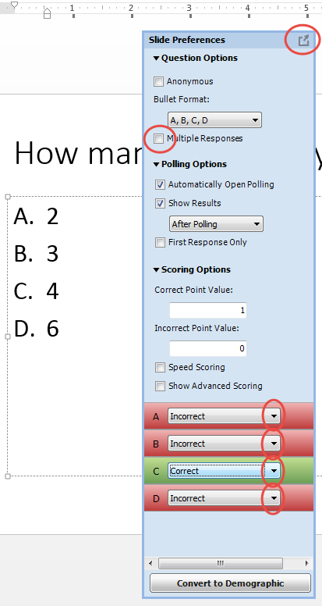Click in the area where you entered the answers (there will be a bounding box around the area). A Slide Preferences menu should display. If the preferences do not fully display, you may need to expand the menu (top right corner).
4. Choose Question Options (bullet format, multiple responses (if needed), Polling Options, and Scoring Options. Use the dropdown arrows to select the correct/incorrect answer(s).

You will now select an answer indicator for your audience to see.

1. Select **Objects** from the File menu, Correct Answer Indicator, choosing your preferred indicator as listed in the submenu.
   * (When choosing an indicator, keep in mind the size of your room and the audience distance for viewing; ex: a yellow smiley face may not be easy to see from someone sitting in the back of a large room.)

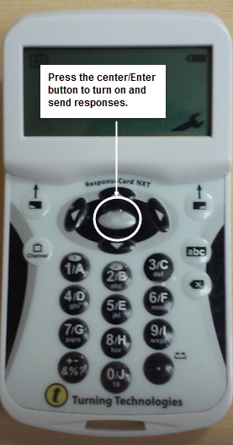Your indicator should now display next to the correct answer.

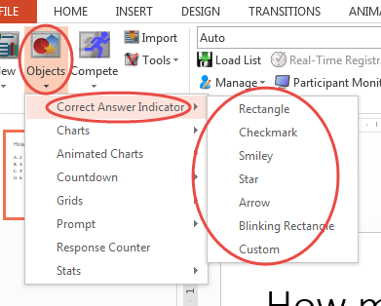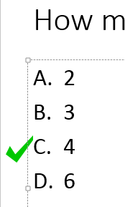

1. Repeat steps 3-8 to add additional question slides, selecting answers and answer indicators

**Ready to test it out?**

You will need a set of the clickers to test your presentation.

Have your “clickers” ready to respond as indicated in the image to the right by pressing the center/Enter button.

1. Plug in the receiver (looks like a flash drive) into the computer.
2. Start your presentation…**Slide Show** menu, **From Beginning**.
   1. 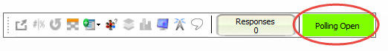Your response menu will display and “Polling is open” by default. You can drag this menu anywhere on your screen.
3. Read the question and enter a response (A, B, C, D, etc.) and press send.
4. Once all responses have been “entered/sent”, click the slide to close the “polling”, and reveal the response feedback as an example in the images below.

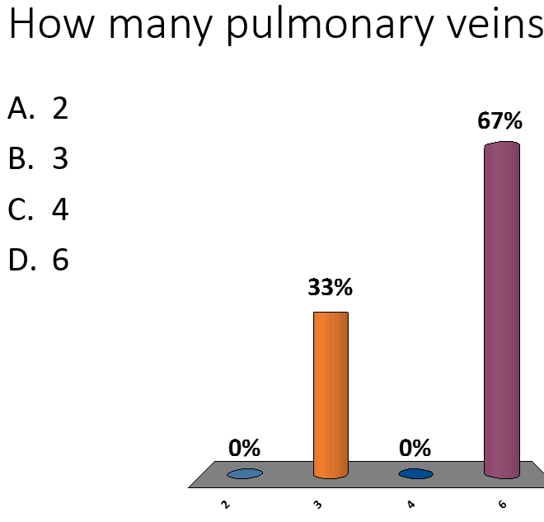

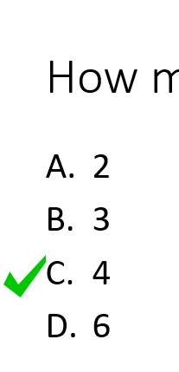

1. Click the slide again to reveal the correct answer(s).

Repeat steps 3-5 to display the question, reveal the responses, and the correct answer for each question slide.

**In The Classroom**

* **CLEAR THE PREVIOUS SESSION DATA**
* **Please follow the directions in the clicker set to reset your “clicker” session, before beginning the clicker presentation with students.**

**Repeat steps 1-5 in the classroom.**

**HAVE FUN!**