Yuja and Closed Captioning
In this quick guide, you will learn how to edit the closed captioning of your recorded lecture.
From Your Recorded Lectures
By default, Yuja will automatically add closed captioning to your recorded lectures. By annunciating and speaking a little slower than normal, Yuja will produce a fairly accurate closed caption.
- Log into your my.yuja.com account.
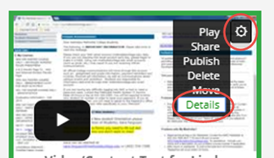
- Locate (do not play) your
- video/recording in your Default folder.
- Click the “gear” (options menu) located in the upper right corner of the video.
- Select “Details” from the drop down menu.
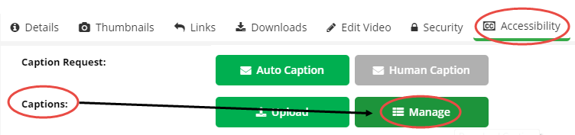
- Select the “Accessibility” tab.
- From “Captions:”, select “Manage.”
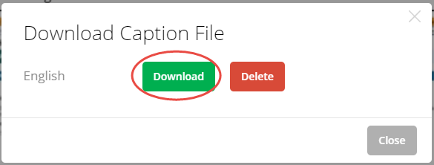
- Select “Download” to download the caption transcript.
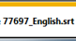
- Be advised, this file will download with an .srt extension (file) containing a series of numbers in the file name similar to the image to the right. DO NOT RENAME THIS FILE
- Save (do not rename this file) the file to your desktop for easy access and quick identification.
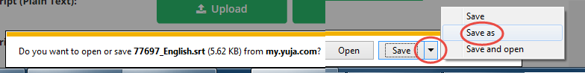
- Close the download window/area.
Editing your Closed Caption Text
Since the downloaded captioned file ends with an .srt extension, you’ll use WordPad to edit the captioned text. You’ll first need to locate WordPad on your computer.
- Click the Windows Start Button.
- In the Search area, enter “WordPad”, and click the Search icon.
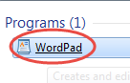
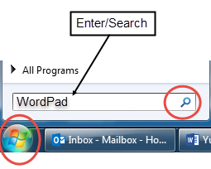
- Click to open the WordPad program.

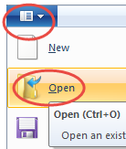

- Click the dropdown arrow on the file icon and select “Open”.

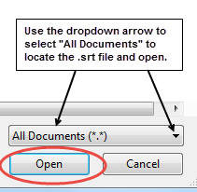
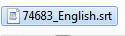
- Locate the XXXXX_English.srt file changing the “type of file” to “All Documents” and click open.

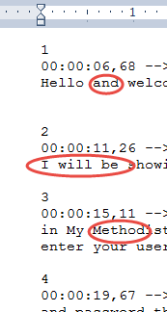
Note the file displays numbered sections, number series, and text.
- Review and edit ONLY THE SPOKEN TEXT as necessary. DO NOT change the section #’s, or the numbers that appear in a series.

- Continue to edit the text as necessary.
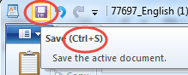
- When editing is complete, click the Save icon, OR press Ctrl + S to save this original file, to the original location on your desktop. DO NOT RENAME this file.

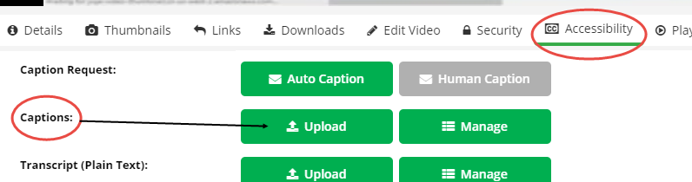
Deleting the Old and Uploading the New Closed Caption

- Return to your video, select the “Gear (Options)” and “Details” from the dropdown menu.
- Select the Accessibility tab.
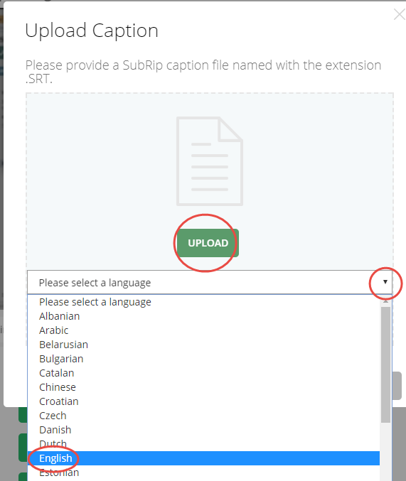
- Return to the Captions: Category, select “Upload”. (Delete the old version if the option is available.

- Use the dropdown arrow to select English as the language for the closed caption.

- Click “Upload” locating the edited XXXX_English .srt file.
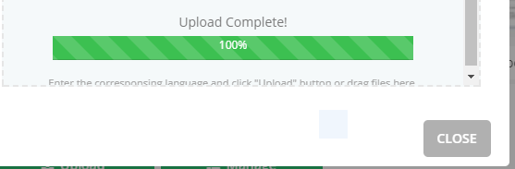
- Once the Upload is confirmed, you can close the caption window.
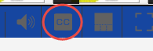
- Return to your video folder, play your video selecting the Closed Caption tool to check your edited captioning.

