Web Ex Polling
You can poll attendees in your session at any time during a session by presenting them with multiple choice, multiple answer, or short answer questions. Be advised: Polling does not work on any mobile device.
You can create Polls in Web Ex using any of the following methods:
- Poll Editor – a standalone version creating question outside of a training/meeting that can be saved locally and imported/opened during a Web Ex session.
- Polling Panel - Create a poll in a session (no attendees have to be present), and save it to a location to be used at a later date.
- Anytime Polling – create poll questions at any time during a session
Poll Editor
- If you are using an NMC computer, you’ll need to contact NMCHelp@methodistcollege.edu to install the Web Ex Poll Editor.
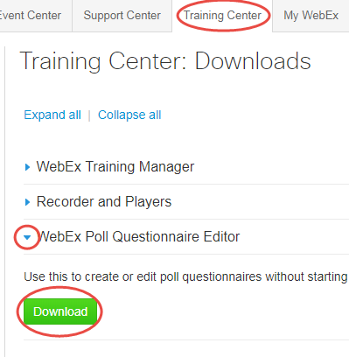
- If you are using a personal computer, login to Web Ex, selecting the Training Center tab. Use the dropdown arrow for WebEx Poll Questionnaire Editor to locate the download.

Create Poll Questionnaires
- Launch the Poll Editor program.
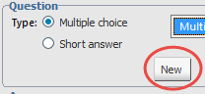
- You’ll first need to choose the question type: Multiple Choice - Single/Multiple Answers, or Short Answer questions.
- Click “New” to enter your question in text box.

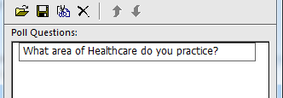
- Enter your question into the text box displayed.
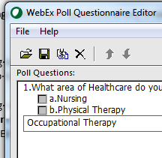
NOTE: Pressing the Enter key after entering a question, ends the question text, and prepares for the entering answers. Pressing the Enter key after entering an answer, ends an answer and prepares for an additional answer.

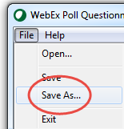
To edit/delete a question/answer, select the question/answer and use the Edit or Delete tool from the Editor menu.
Adding Additional Questions/Answers
Click “New” each time you’re ready to add additional questions, selecting the appropriate type and options for each.
When your poll is complete click File… Save As, name your poll and save to a location on your computer.
The file extension is .atp. Do not change this extension.
Polling Options
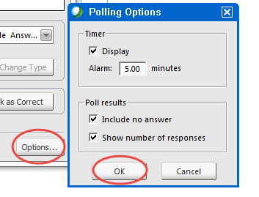
Consider your options for polls.
Options... are located in the bottom right corner of the program.
You can change the answer time for the poll displaying the time to your attendees, include “no answers” (responses), and show # of responses in your results.
Make sure to save any changes you make (or cancel).

Using the Polling Panel for Before or Anytime Polling
If you don’t have Poll Editor, you can still create polls in a live session (no participants have to be present), or open an existing saved poll. Be advised: Creating a poll in a session must be saved to a location, the poll is not saved with the session.
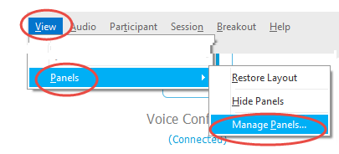
Start your Web Ex session.
- Display your Polling Panel by selecting the “View” Panels, Manage Panels…
- Add Polling to the list of current panels.
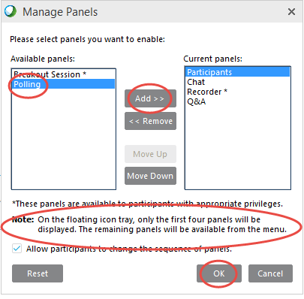

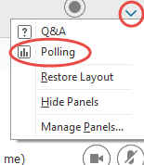
- Select the “dropdown arrow (top right corner) (More Options and Controls) and select Polling. Your Polling panel should now display in your session.

- Select the Question type, and click “New”.
- Enter your question in the text area of the Poll Questions window.
  - NOTE: Pressing the Enter key after entering a question does not begin a new line, but ends the question, and prepares for entering answers.
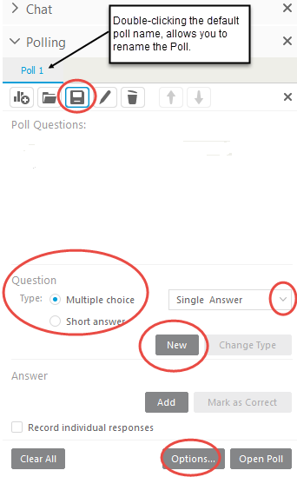
  - Pressing the Enter key after entering an answer, ends an answer and prepares for an additional answer.
By default, the poll is named “Poll 1” as shown on the tab. You can double-click this tab to rename the Poll.
Add additional questions by again choosing the Question type, and clicking “New”.
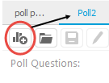
To edit/delete a question/answer, select the question/answer and use the Edit or Delete tool from the polling window.
To create/add an additional poll(s) select the New Poll tool from the toolbar.
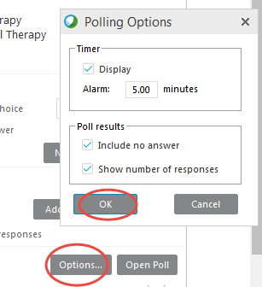
Polling Options
Consider your options for polls.
Options... are located in the bottom right corner of the panel.
You can change the time for the poll, and display this to your attendees, as well as include “no answers” (responses), as well as show # of responses.
Make sure to save any changes you make (or cancel).

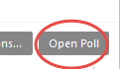
Administering the Poll
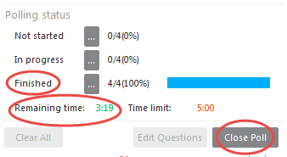
When you are ready to administer your Poll… click “Open Poll”
When all participants have responded (or time expires), Click “Close Poll”.

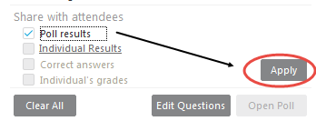
To share the results with participants, check “Poll Results, Apply”.

Note: If you choose to “Clear All” (results), you will be prompted to save/not save the poll results, but the Poll will be deleted from the Polling panel.

