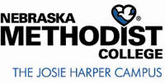
POLICIES AND PROCEDURES

SUBJECT: External Email Survey Etiquette

REVIEWED/REVISED: 2/2018

PURPOSE: To establish a consistent procedure for managing email surveys received at the college from external sources.

External emails from researchers, including but not limited to, graduate students, faculty from other institutions, healthcare providers, etc., requesting to survey Nebraska Methodist College (NMC) students, faculty, or staff must be forwarded to the NMC Institutional Review Board (IRB) at IRB@methodistcollege.edu for approval.
External emails from known vendors or professional organizations requesting information (i.e. surveys, customer service inquiries, service or product satisfaction, etc.) to individual faculty or staff may be distributed without IRB approval.

