How Learning Profiles Can Strengthen Your Teaching
AUGUST 13, 2014
Share95
1
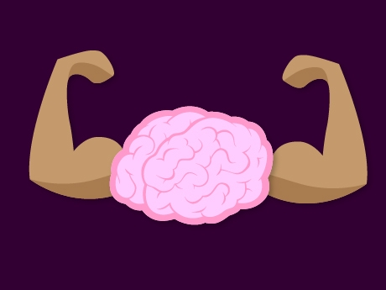
There is a small belief that learning profiles do not exist or, if they do exist, they have no place in classrooms. The truth is that every teacher witnesses students learning in different ways. For example, when I’m learning abouteffective blended learning practices or how not to overcook salmon, I will turn to a variety of resources. I’ll watch videos, read articles, talk to different experts via social networking, and look over models that make sense to me. I have a better chance of learning when I use a combination of these learning modalities rather than using just one.

Offer an Entry to Learning
We all have similar experiences when learning. Some learning approaches simply work better for us than others. If we learn through a variety of ways, then so do students. Therefore, our lesson planning should reflect a variety of ways to offer entry to learning by all students. If you know that a student builds understanding best when she can watch a demonstration and then dialog about the content and it’s implications, you should provide that experience. While each student has different approaches to learning, learning preferences do overlap in groups of students. The result is activities that are accessible for small and large student groups.
We can start using learning profiles when we know the various ways that each of our students makes sense of content. The more we understand our students, the more efficient we can ensure their learning successes. When we have in-depth understanding for how our students learn, there is a major impact on diagnosing student needs and planning effective supports. Multiple intelligences and thinking styles inventories can be effective tools for gathering data about students. Here a sample of approaches to find what fits your instructional belief system:
- Sternberg’s Triarchaic Theory of Intelligences
- Bernice McCarthy’s 4-Mat
- Howard Gardner’s Theory of Multiple Intelligences
- True Colors
- Meyer’s Briggs
As soon as this learner data is collected, you can start differentiating lessons in ways that intentionally and strategically improve student learning.

Cross-Train Learning
Everyone learns through a variety of approaches. Placing learners into a single learning style container ignores the reality of the whole person. Teachers need to cross-train students by using two or more approaches to thinking styles profiles when planning differentiation. The more we know about our students, the more we can be effectively strategic in meeting everyone’s needs. This is where learning profile cards, student profile surveys, and student learning perceptual quick surveys can provide detailed insight about students that spans across multiple thinker processing categories.
Learning profile cards: Completed by students, these cards can give teachers rich detail to inform instructional planning of content, process, and product based on interests and learning profiles. I’ve found this tool to be the best for managing differentiation with large numbers of students.
Student profile survey: Families or guardians complete this survey about their child. Involving the child in the conversation creates a richer response for teachers to support them. When we’ve completed such surveys for our kids, my wife and I have formed a deeper appreciation for those teachers because they demonstrated their commitment to truly meet our children’s learning needs. Here’s an example from Alberta Education.
The student learning perceptual quick survey is a simple and quick 5-15 minute activity to get a classroom view of the students’ learning styles. Students appreciate when the results are posted in a location where they can reflect on them anytime.

Plan Three-Dimensional Lessons
Three-dimensional lessons incorporate a variety of different experiences in a lesson. For example, revise a lesson to teach content in three different ways. This will help all students find ways to connect, and delve into key concepts and skills. Here’s one lesson format example:
- Content: Show a video that gives an overview.
- Process: Summarize the video’s key points in student groups of three, and then share out.
- Content: Jigsaw an article or chapter reading while completing a graphic organizer. Groups share their findings.
- Process: Use think-pair-share to reinforce student understanding.
- Product: Provide three ways to apply the content such as in a RAFT,Think Dot, or Teiring via Readiness.

Embed Choices
When using learning profiles, one guarantee is that all learners fall somewhere on the learning styles range. Design versions of an activity or product that incorporates different aspects of a learning profile. For example, use Sternberg’s MI to create three product options that reflect analytical, practical, and creative. Let students decide which pathway option they want to take. Sometimes, students will choose an option that may not “align” with their learning profiles. This is okay because they are making the choice. Consider letting students design products based on modes of their own choosing. This approach signals to students that their input matters.
The belief that learning profiles have no place in education fails to understand formative assessment data, absent assessment fog, that shows how not all students are achieving. For challenges like large class sizes, high stakes testing, and intense focus on teacher and administrative accountability, increasing success by all students means we must engage them into the learning dialog. The mindful use of learning profiles keeps the light on and the door open for them to learn.
JOHN MCCARTHY'S PROFILE

Taken from: http://www.edutopia.org/blog/learning-profiles-john-mccarthy?utm_source=twitter&utm_medium=post&utm_campaign=blog-learning-profiles-strengthen-teaching-quote [accessed August 14, 2014]

