Adding a Handout(s)/file(s) to your course

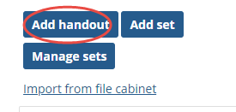
Be sure the “Handouts” feature is added to the course page.
- Select “Add a Handout”. (If you need to add/create a set (category), create/add the set first, then add the handout after the set is created).

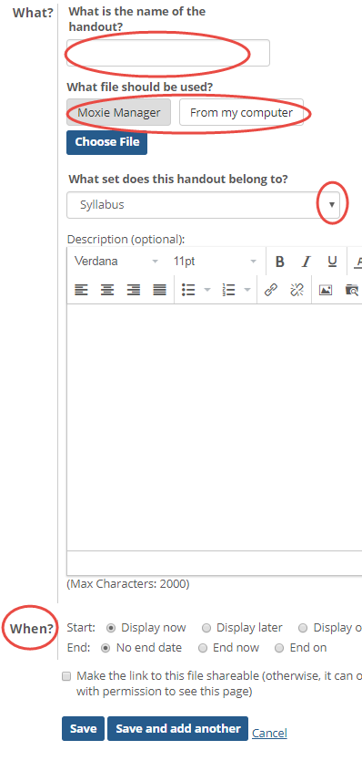
- Enter the handout name
- Select what file should be used from either from your Moxie Manager (internal file manager), or from your computer.
- Select the file from the location you chose.
- Choose the “set” (if applicable). By default, if no set is selected, it will list under “Ungrouped”.
  - Adding a description is optional.
- Choose “When?” the handout is to display if applicable. By default, the handout/file will “display now”.
- Save or Save and add another handout/file.

