Creating an Online Test
(Using Test Builder)

Step 1 (Required)
- Click the Coursework page, click "Add an Assignment".
- Select “The Online Test format”.
- Enter the test name.
- Use the dropdown arrows, to select the Unit (Week 1, Exams, Quiz etc.), and Type (required, optional, extra credit.
- Enter the due date, (or click the Calendar for date selection) time, and whether to show this due date in the course calendar. You also have the option to accept late submissions.
- Enter when you want the test to be available:
  - Immediately – Now
    - (You cannot set the activation to “Now” until the test has been created.)
  - Unspecified – Later (must be started manually)
  - Based on rules I define – Can be a specific date and/or assignment
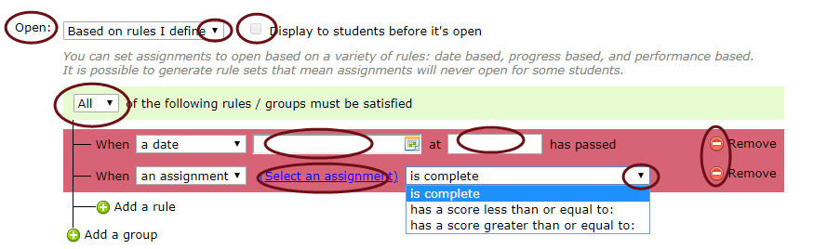
  - Display to students (visual reminder only, no access).

- Grading: The online test format is graded automatically.
- Show Grade: Use the dropdown arrow to change from the default, “as soon as grade is available”.
Step 2 & 3 Online Assignment Options (Optional)
- Click Step Two, to select additional options for test review, time limit, pagination # of test attempts, etc.
- Click Step Three, to enter a description, instructions, and a relevant file(s).
- Scroll down and “Save your assignment.” The Test Builder will open to create your test.
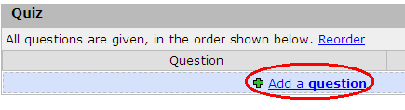
Adding Test Questions
- Below the section name (Quiz in this example), Click, “Add a Question”.
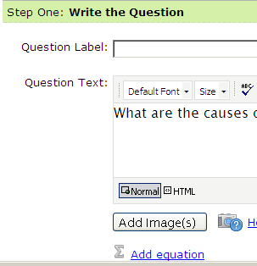
- Step One: Write the Question
  - Enter a Label (highly recommended). A Label is not visible to students, but to help you identify/edit a question (such as #1, #2, etc.). If you do not create a label, the label will be created by duplicating the first few words of the question.
- Enter the Question Text. (You can include images, and/or equations into the question). You do not need to enter a question #, as Test Builder will auto number questions in a test.
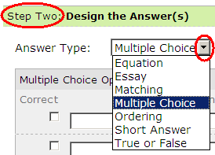
- Enter the Point Value Note the option below the point value allows you to make this question extra credit).
- Step Two: Design the Answer(s) Answer/adding feedback options will vary depending on the Answer type
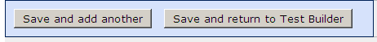
  - Multiple Choice (also is used for multiple select) is the default Answer type.
  - T-F, Matching, Essay, etc.Use the dropdown arrow to select other answer types.
  - Use the green + to add more answer type items if needed, or use the red X to remove/clear unneeded answer types.
  - Note below: Depending on the answer types, you have options to Randomize answers, give Partial Credit answers, and/or Limit Selections. You can also preview a question.
- Step Three (Optional)
  - Automatic Feedback, click to expand available options.
- Save and add another question, or save and return to Test Builder. Once the assignment is saved, Test Builder displays with the entered questions.
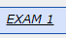
Adding/Editing Questions/Answers
To add/edit questions/answers to an existing online assignment, click the assignment name.
- Click “Go to the Test Builder”,
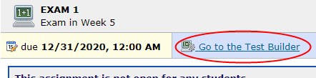

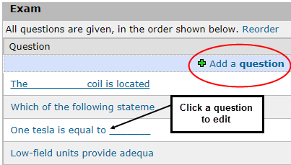
- When your online test displays…
  - Click “Add a question, or click an existing question to edit the question text, point value, and/or answer type (answers).

Be sure to scroll down to Save and view next, or Save and return to Test Builder.

