The Forums (Discussion) Feature
Forums are organized by categories and sub-categories called topics. For example, the “Category” might be “Heart Disease”, and the topics in this category could be “Early Signs of HD”, “Acute Coronary Syndrome” etc. Students then post/respond within the individual topics in the category.
- Select the page to add the Forum feature.
- Click the menu tool, (wrench)… Add a new feature…” selecting the Forums from the list. (You might consider renaming this feature to “Week 1 Discussion, Diabetes Discussion”, etc.
- Click “Back to…” to return to the page and the Forums feature displays.

Adding/Editing a Discussion Category and Topic(s)
- Click the Forum title bar. A default category (General) and topic (Open discussion) display.
- Select "Edit Forum" link to add/edit a new category/topic. Save.
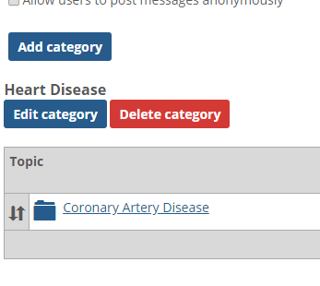
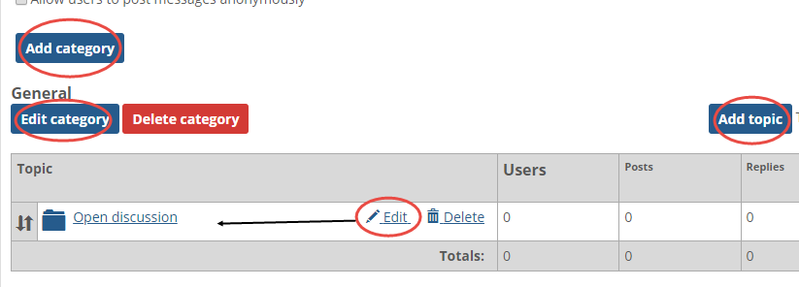
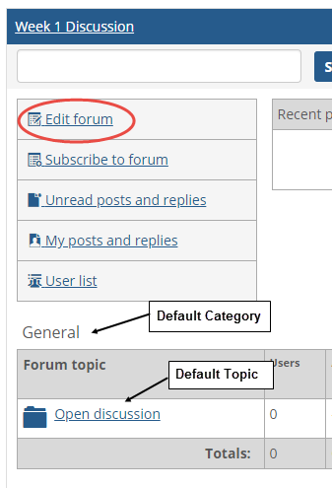
- Edit/Add a Category, and/or Edit/Add a new topic. Save.
Repeat steps 1-2 to add/edit additional categories or topics.

YOU MUST….Grant Access to Students to Post/Edit own/Reply
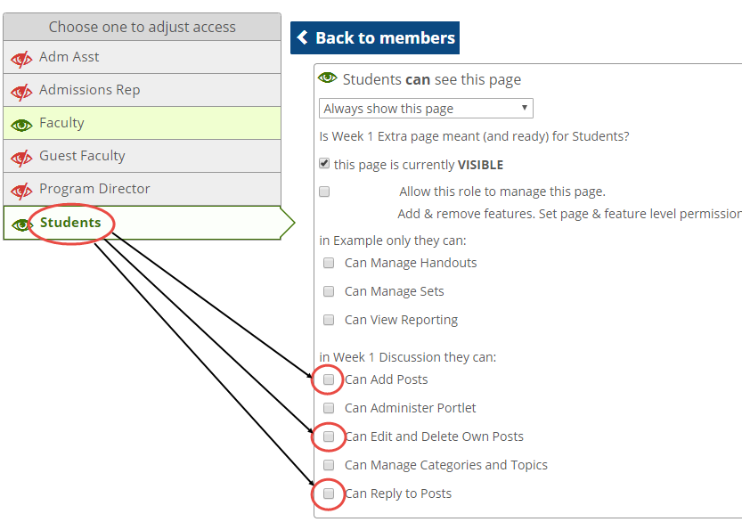
By default, students CANNOT post to Forums until the instructor has granted access. The access varies from Adding a Post, Editing/Deleting their own Post, and Replying to Posts
- Select “Access” from the page menus (wrench).
- Select “Students” from the list on the left.
Scroll down to the Discussion and select permissions accordingly.

