How to Submit an Upload File Assignment
Overview
Dropboxes in My Methodist are known as “Upload Assignments”. This Upload assignment is found only on the Coursework/Assignments page of a course.
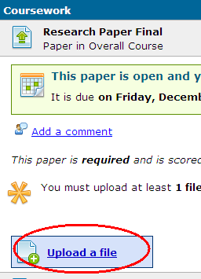
An upload assignment is identified by a double arrow icon.
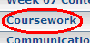
Submitting a File
- Click the Coursework page of your course.
- Click the Upload File assignment.
- Click Upload a file
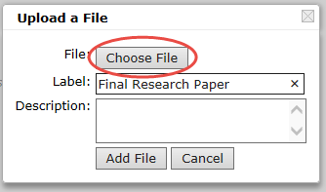
- Enter the Label (assignment name), and click “Choose File”.
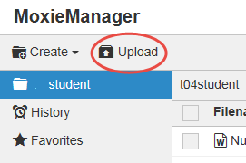
- When “Moxie Manager” appears, click “Upload”. Locate the file on your computer. By default, the file will be selected with a checkmark and displayed in a list in Moxie Manager. If you need to add more than 1 file for this assignment, repeat this step to add the file to your list
- Select the file and click “Insert”.
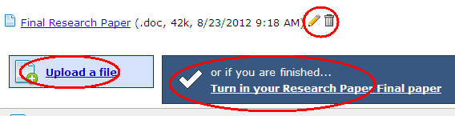
- Repeat steps 2-6 if this assignment requires more than 1 file. Your file/files will appear on the assignment.
- If/when you are finished uploading your file(s), click the “Turn in your .........paper” link to submit the Upload file assignment.
Your file(s) will list as confirmation of your Uploaded files..

