Using WebEx for Your Online Meeting
Student Version
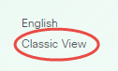
To join an online meeting, go to:
- https://nebraskamethodist.webex.com. Click the “Classic View” link if displayed on the left of your screen.
- Enter the Session Number (no spaces) in the space provided and click “Join”. You will then be prompted to enter the Session password and then click “OK”.
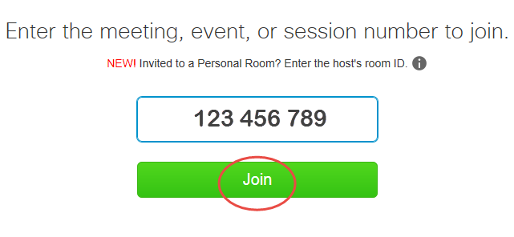
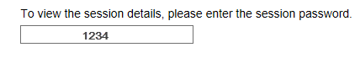

Continue by entering your name, NMC email address and the session password.
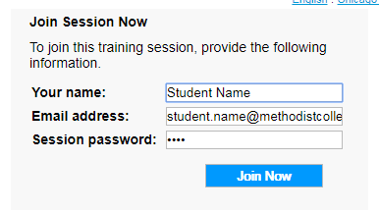
At this point, you may be prompted to either install, or run a temporary setup to join this meeting. Whether you are using Internet Explorer or Chrome, you’ll need to choose the appropriate option for the computer you are using. If you are using an NMC computer, choose “Run Temporary” application.
Once you install/run temporary application….be patient… it takes a moment to connect to your online meeting. The meeting “dashboard” will open in a separate window.
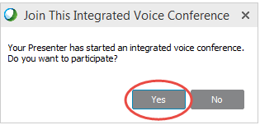
Choose Yes to participate in the online meeting.

Navigating Your Web Ex Online Meeting
Upon entering a meeting, the Web Ex Dashboard will display. From the dashboard, you can view a Host/presenter/panelist’s screen, as well as chat, respond, and ask questions throughout the online meeting. Depending on the permissions granted when your meeting is created, the features may or not display as in the image below.
Take a moment to familiarize yourself with the Web Ex meeting dashboard.
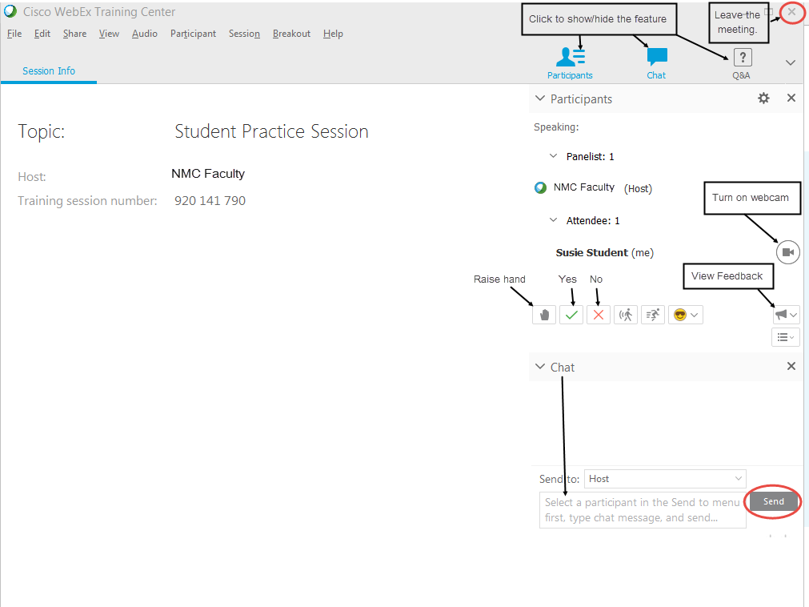
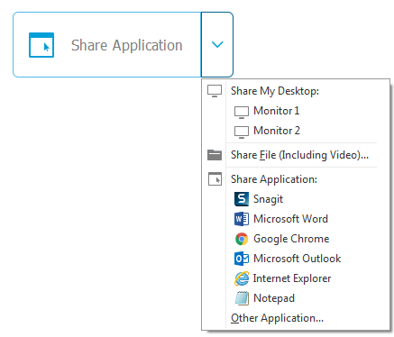
Sharing Your Desktop
If the Host changes your role to a presenter. you will have the option to share your desktop/application for others to view on their screen.
Use the dropdown arrows to choose the appropriate action.

