**Using Web Ex for Online Meetings (Training)**

Cisco **WebEx** is the leading enterprise solution for video and web conferencing. Participants can join from any browser, device, or system. **NMC recommends using Internet Explorer or Chrome when conducting an online meeting. NMC does not support Firefox or Safari.**

When conducting a Web Ex session with students, you’ll use the **Training Feature** in WebEx. Sign in to your NMC WebEx account: [**http://nebraskamethodist.webex.com**](http://nebraskamethodist.webex.com)

**MODERN LOOK UPDATE**

The landing page for our Web Ex has changed slightly to a “Modern View”. The Sign in page may look different, as well as your “home” page once you’ve logged in.

Please note the images below to reflect this change and switch to the “Classic View” once you’ve logged in.

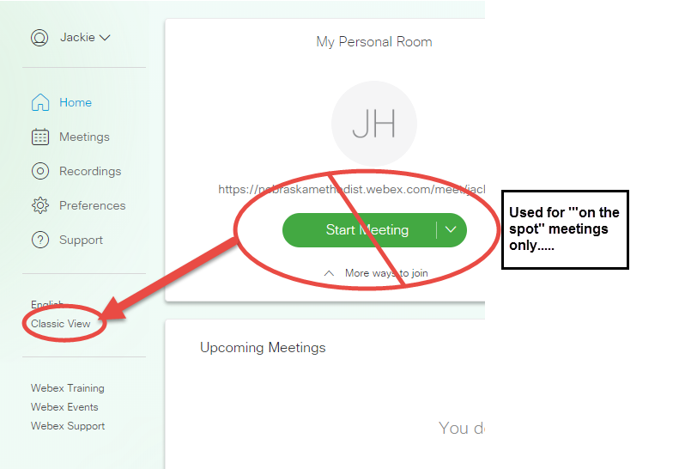

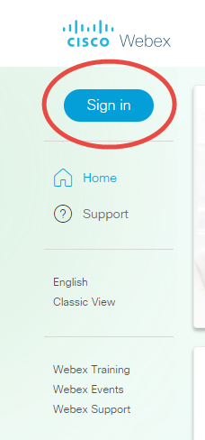**The next page reflects the signin for the “Classic View”**

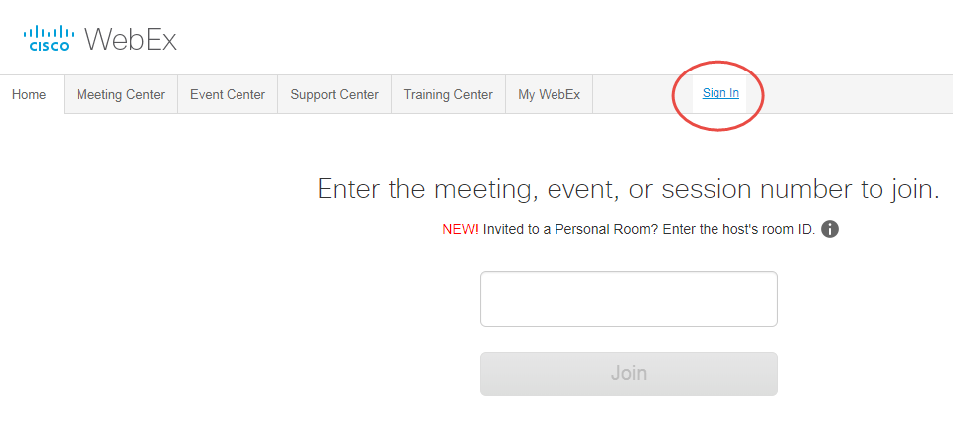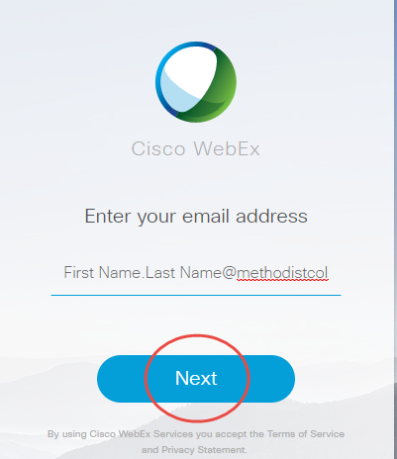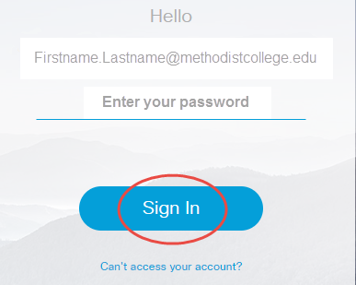

1. 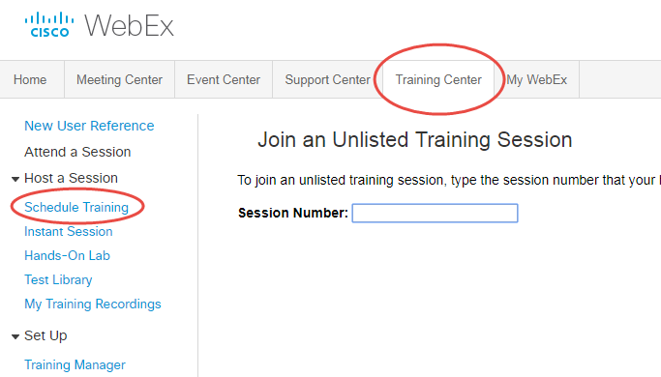Select the Training Center tab.
2. Click “**Schedule Training**” from the left of your screen.

To Schedule the Training Session, **pay close attention to the options** available.

1. Enter your session topic as appropriate. The areas circled in the image below are areas that are either required, and/or important scheduling considerations.
   * 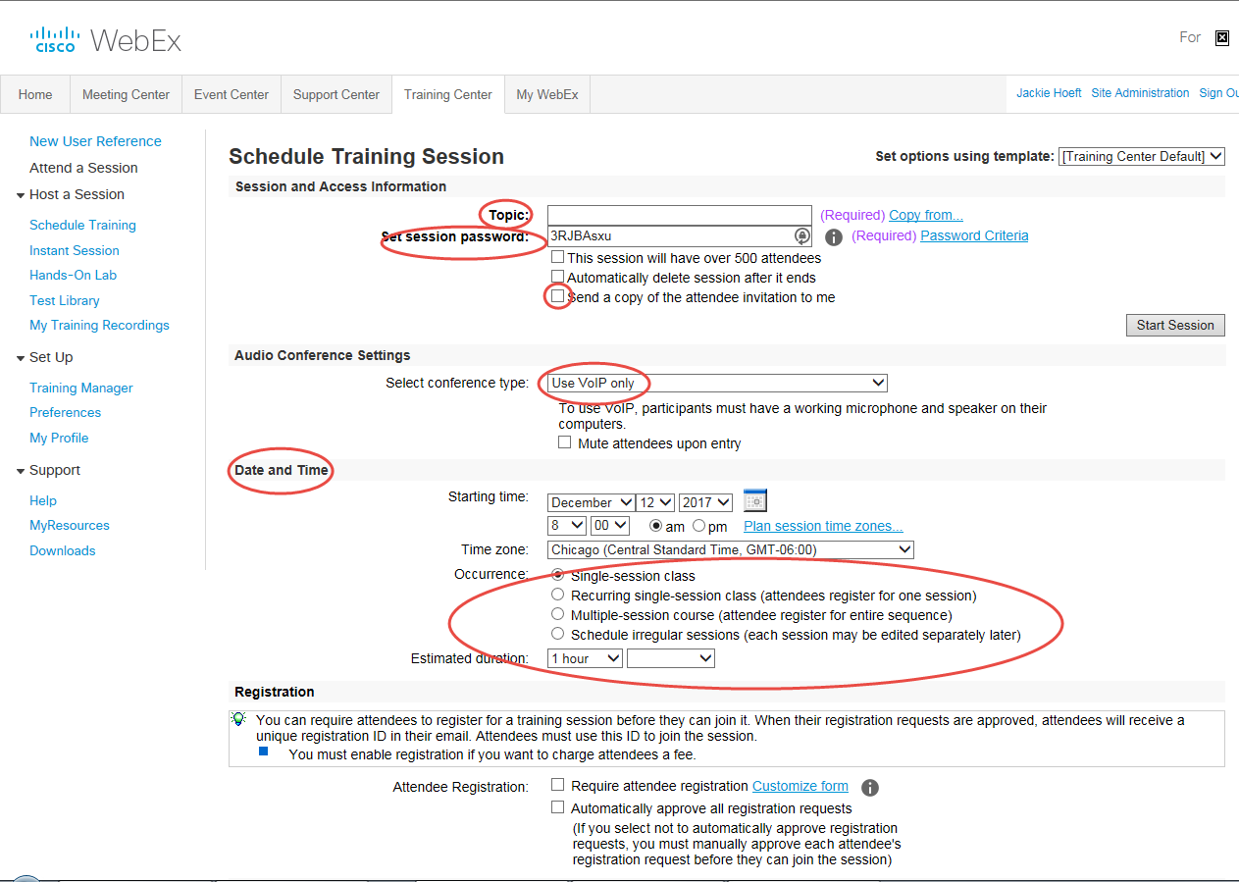Attendee registration is not required. **If you send a copy of the invite to yourself, you can forward the invite to the attendees, or copy/paste the join information into your course in My Methodist.**
2. ***Scroll down to select additional options*** *for inviting specific attendees, presenters, selecting available session features, editing the greeting message, selecting Breakout session assignments, and adding Course Material, and/or Tests.*
3. When all options have been selected/edited, click “**Schedule**” to save your session. You will receive the Training Session confirmation/information to your NMC email, **as well as a “forwarded” email if you sent a copy to yourself.**

**Adding the Meeting Information into your Course**

From the copy of the invite that was forwarded to your email, you will copy/paste the top “section” into your course that contains the **Session number**, and **Session Password** (see image below).

* + 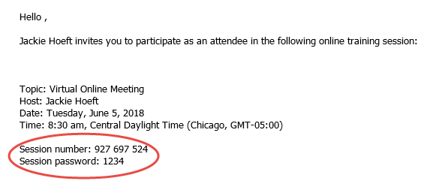***NOTE:*** If students receive this invite to their NMC email, **(due to multi-factor authentication), the link will “spool” behind the portal and go nowhere. Placing the join link (as done previously) into your My Methodist, will have the same result**

1. 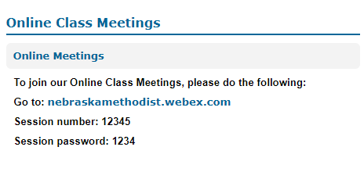In your course, instruct students to go to: nebraskamethodist.webex.com and enter the session number and password. See the example image to the right.

***(NOTE…. There is no “college” in the web address).***

1. 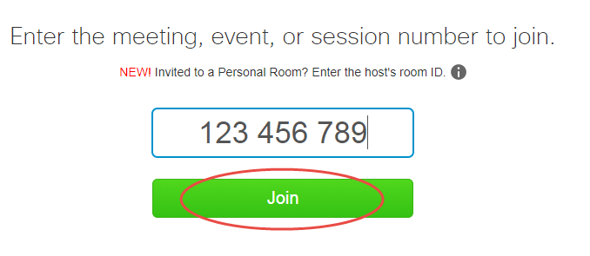**Students will enter the session number and click “Join”.**
   * Students will enter the session password, their name, NMC email address.

*Students will not be able to join a meeting/session unless the instructor/host has started the session.*

**Starting your WebEx Meeting/Training**

1. 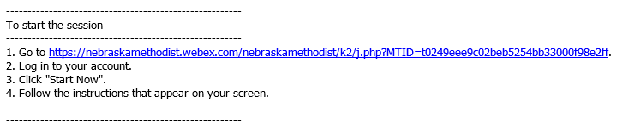You can start the meeting from your confirmation email *(highlight/copy/paste link text from NMC email into the browser if you are off campus).*

**OR**

1. Sign into your NMC Web Ex **account:** **nebraskamethodist.webex.com**
2. Select the Meeting Center tab, My Meetings from the left of your screen.
3. From the meetings listed, click “**Start**” from the right of your screen.

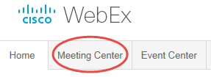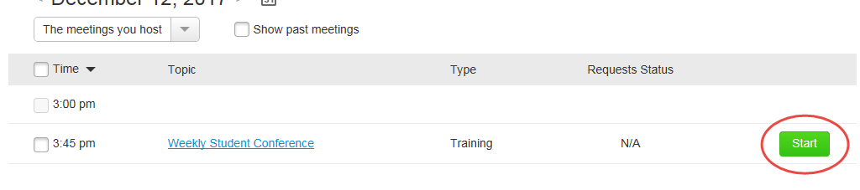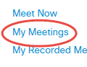

**or**

* + 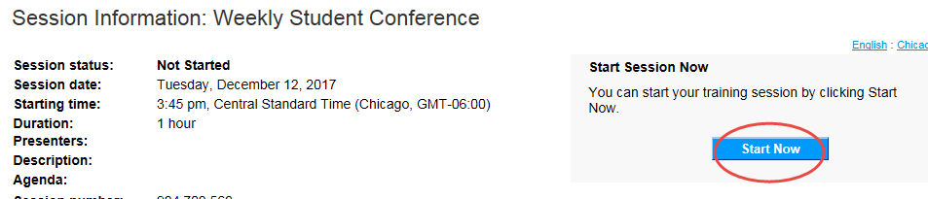Click the meeting topic/title and “**Start now**”.

***NOTE:* Your WebEx meeting/training will open in a separate window. The image to the right is the window displayed on your screen.**

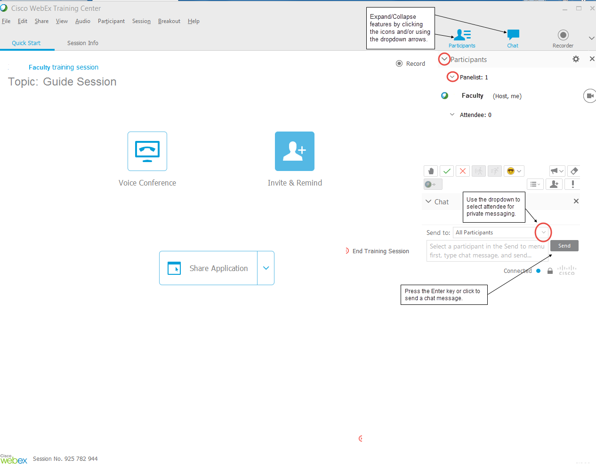**Your WebEx Meeting/Training Window**

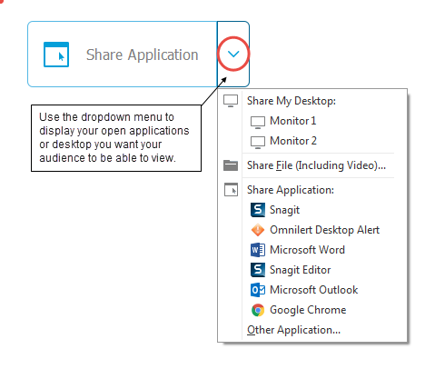**Sharing Your Screen**

Be sure the application/program you want to share with your attendees is open on your computer. When you’re ready, click the “Share Application” dropdown and select the program.

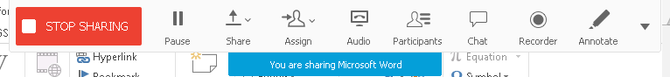**Once the shared view begins, your toolbar will collapse/hide into the top of the screen.** Direct your mouse close to the top of your screen to unhide/expand the menu/navigation.

Click “Stop Sharing” when finished.

**Recording Your Meeting/Training**

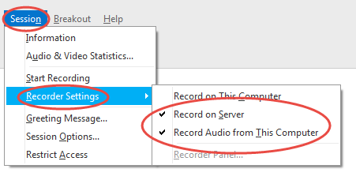***Note:*** Due to the Web Ex recorded file format, **you will record/save your session to a Web Ex server.**

1. Before recording, be sure to check your Recorder Setting from the Session menu.
2. 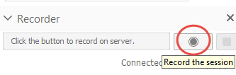Select the Recorder feature/icon from the panel,

**OR**

select “Start Recording” from the Session menu.

You’ll know you’re recording as the Recording button will be red in color.

1. 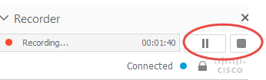Click the Pause/Stop recording buttons as appropriate. When you stop the recording, you will be prompted for confirmation to stop the recording.

**Locating your Recorded Session**

**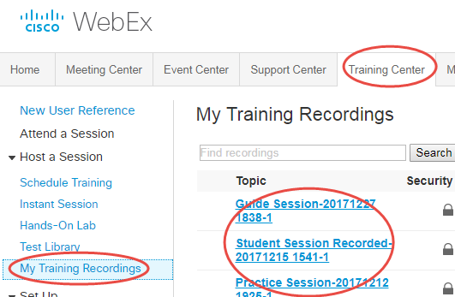*NOTE:*  WebEx will generate a password for access to your recordings. You will not set this password.**

1. Return to the Training Center tab and click “My Training Recordings
2. Select the appropriate recorded session link.
3. 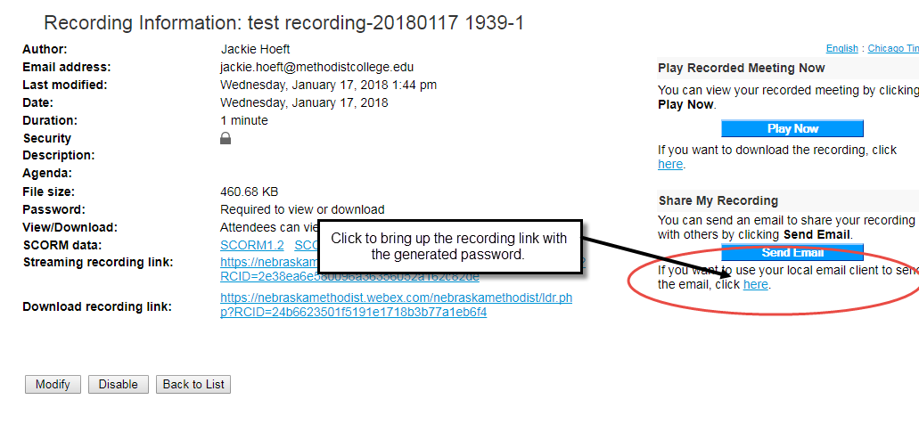From the Recording Information window, select “click here” to open an email with the access information to the recording.
4. From the information that displays in an email, you can send this to students, or you copy/paste the information into your course in My Methodist to again avoid multi-factor email issues.

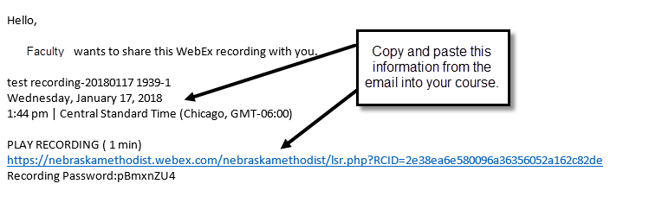

**Granting Presenter Rights**

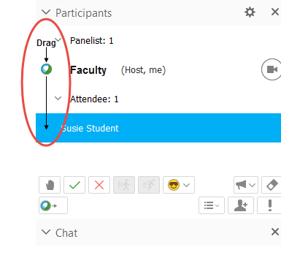At times you may find your students need the ability to present to the rest of the class. You can grant temporary “Presenter” rights so the students can share their screen to display their presentation.

1. Since you are the “Host/Presenter”, drag and drop the blue ball icon from your name to the appropriate attendee. (You can also right-click the attendee and “change their role”.)
2. 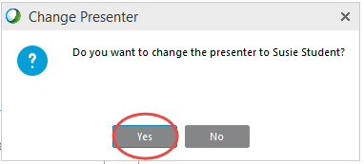Confirm the change of Presenter.
3. **When this presenter is finished**…. drag the blue icon to another presenter, or back to yourself. Be sure to confirm the change.

**Ending Your Meeting/Training**

To end the meeting click “End Training Session”, (or click X in the WebEx window). Confirm to end the session when prompted.