**YuJa**

**Lecture Capture**

**Prepare:**

* **You must have a YuJa user account.**
  + Contact [NMCHelp@methodistcollege.edu](mailto:NMCHelp@methodistcollege.edu) for a user account.
* Your computer must have a web camera (built in, or webcam) and microphone (built in microphone, webcam microphone, or headset).
* The **YuJa Software Station** program **must be installed on your computer**.
  + If you are using an NMC computer, notify NMC Help for installation due to administrator rights.

*****For a personal computer****,* you can download and install the program after logging into my.yuja.com with your YuJa account.

1. 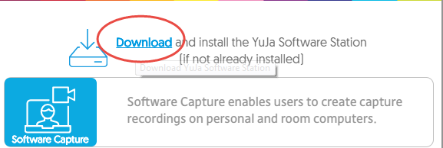Click the “Create Recording” icon,
2. From the menu select, Download.
3. Install the software station to **your personal computer**.

* **Tips for a successful recording:**
  + Be sure your recording space is free of distractions, and background noise (phones ringing, dog barking, conversations, etc.)
  + Turn off email notifications if you are recording your screen.
  + Speak normally, and clearly. You might also consider speaking a little slower than normal, if using CC (closed captioning).
  + If you are capturing/recording a slide presentation/document on your screen, **have the presentation open and ready.** It’s also a good idea to pause a couple of seconds between slides/pages.
  + If using a headset, be sure to position the mic closer to your chin to avoid puffs of air going directly into the mic.
  + ***Best practice recommendations*** lecture capture should be no more than 15-20 minutes in length. You can always record additional “parts” (Part 2, Part 3, etc.) as needed.

**Let’s Begin!**

Launch the YuJa Software Station from your task bar or desktop.

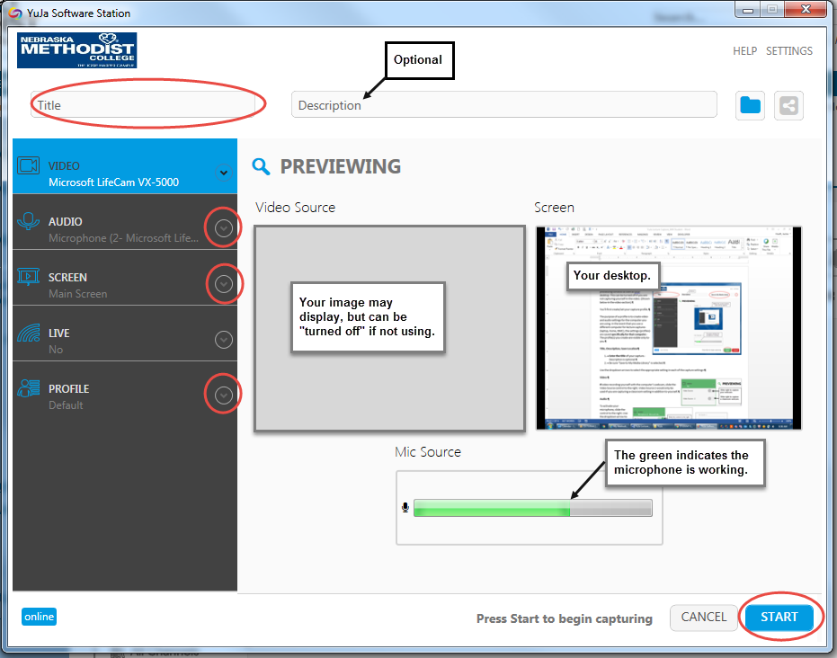**Creating/Setting a Capture Profile**

The purpose of a profile is to create/save video and audio settings for the computer you will be using. If you could be using different computers for lecture captures (laptop, home), the settings (profiles) are saved **specifically for that computer**. The profile(s) you create are visible only to you.

The default/Preview window, saves your lecture capture to your Media Library (cloud).

**Title, Description, Save Location**

1. **Enter the title** of your lecture/capture. Description is optional. Your capture will save to your Yuja Cloud account.

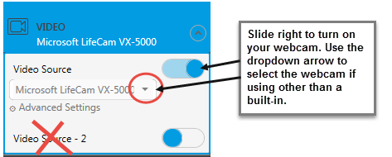**Settings** (Displayed/listed to the left of the preview window.). Select the dropdown from each listed setting:

**Video:**

If video recording yourself, slide the control to the right.

If/in addition to, you are capturing the classroom, slide the control to the right for **Video Source -2**.

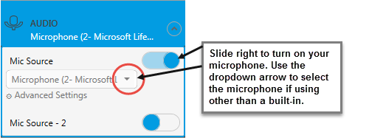**Audio:**

To activate your microphone, slide the control to the right. Use the dropdown arrow to select the microphone on your computer. (Your preview window will display green in the area indicating your Mic has been recognized.). Mic Source 2 is used if you are recording classroom audio also.

**Screen:** (Record your computer screen)

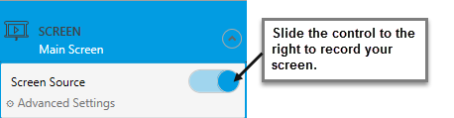Slide the control to record your computer screen. If you have dual screens (two monitors), use the advanced settings to choose which screen you will want to record. Make sure your presentation/document displays on your chosen screen and save your selection.

**Live Streaming**? Probably not.

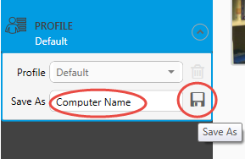

**Save/Name Profile:**

Enter the name of the computer you are using for this capture. If you have a previously saved profile, use the dropdown arrow to select the computer you will be using.

**READY TO CAPTURE?**

Click Start to begin your lecture/capture.

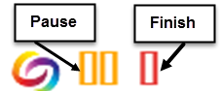Once the capture begins… look for the small control menu located at the bottom right of your screen.

* Press **Pause** if you need to pause, or **Finish** when your capture is complete.

**Saving/Deleting Your Recording**

Once you’ve “finished” your recorded lecture you will be prompted to Save or Delete this capture. Choose the appropriate option.

**Accessing Your Recorded Lecture Capture**

Your saved capture is located in your Yuja Cloud (online) account. When your capture is finished processing, and ready for viewing, **you will receive a confirmation email**. **Please be patient**, the longer your capture, the longer it will take to process into a video format.

1. 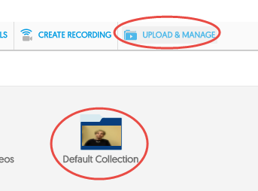Login to my.yuja.com

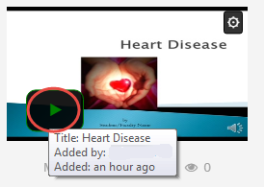

1. Click the “Upload & Manage” link in the top right corner of your screen
2. Double-click the Default Collection folder to display your recorded video(s).
3. 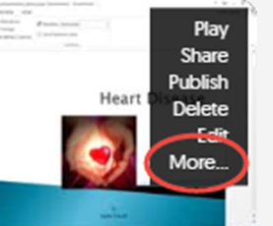Locate your recorded video. Click the play button to preview your video. Return to the Default Collection.

**Video Link/Access**

1. Place your mouse over your video .
2. From the dropdown menu Select “**More…**.
3. 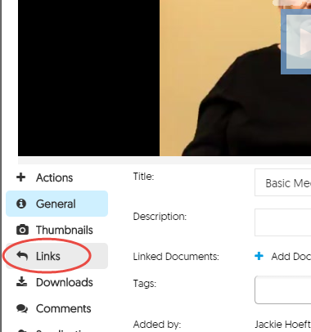Click the “Links” tab to the left of your video.
   * 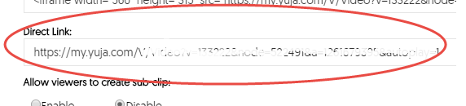**Copy the Direct Link and paste as a Bookmark (or hyperlinked text) in your My Methodist course**.